VARUVAN VADIVELAN INSTITUTE OF TECHNOLOGY

**NAAN MUDHALVAN: IBM**

**TECHNOLOGY:** DATA

SCIENCE

**PROJECT: INNOVATION FOR COVID-19 VACCINE ANNALYSE**

**INTRODUCTION:**

Achieving high uptake of COVID-19 vaccines requires effective planning, coordination, and implementation of a range of strategies.

**The toolkit covers:**

Developing and submitting a National Deployment and Vaccination Plan (NDVP); Regulatory preparedness; Indemnification and liability; Costing and funding; Supply and logistics; Human resources and training; Vaccine specific resources; Considerations for optimizing the COVID-19 vaccine country portfolio; Vaccine acceptance and uptake (demand); Vaccine safety; Data and monitoring; Evaluation of COVID-19 vaccine introduction

**INNOVATION FOR COVID-19 VACCINE ANNALYSE:**

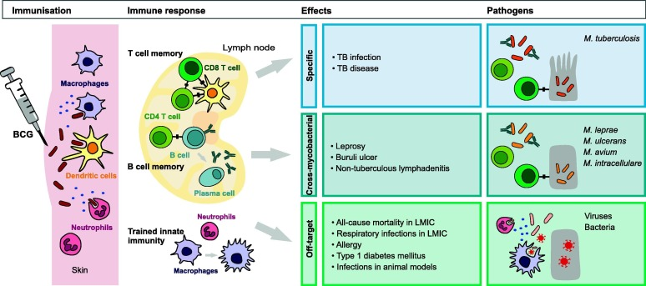

**IMMUNISATION:**

**Key points of analysis include:**

1. **Efficacy and Effectiveness**: COVID-19 vaccines have shown high efficacy in preventing symptomatic and severe cases of the disease. However, breakthrough infections can still occur, especially with emerging variants.

2. **Vaccine Variants and Boosters**: Ongoing research assesses the need for booster shots to enhance and prolong immunity, especially with the emergence of new variants that might partially evade immunity from initial vaccination.

3. **Global Distribution and Equity**: Ensuring equitable distribution of vaccines globally is a challenge. Disparities in vaccine access highlight the need for international cooperation to address the pandemic effectively.

4. **Safety and Adverse Effects**: Monitoring and reporting adverse effects is crucial to maintaining public confidence in the vaccination campaign. Vaccines have undergone thorough safety evaluations, with rare adverse events identified and managed appropriately

**IMMUE:**

Certainly! The immune response to COVID-19 vaccines is a critical aspect of understanding their effectiveness.

1. **Antibody Production**: COVID-19 vaccines prompt the immune system to produce antibodies against the spike protein of the SARS-CoV-2 virus.

2. **Cell-Mediated Immunity**: Vaccines also activate T-cells, a type of white blood cell. These T-cells are essential for cell-mediated immunity, aiding in the destruction of cells infected with the virus.

3. **Memory Cells**: COVID-19 vaccines stimulate the production of memory B-cells and memory T-cells.

4. **Immunological Memory**: The immune system retains a memory of the virus through immunological memory.

5. **Booster Shots**: Booster doses further strengthen the immune response by reminding the immune system of the spike protein, enhancing antibody levels, and boosting immunological memory.

6. **Duration of Protection**: Research is ongoing to determine the duration of protection provided by the vaccines.

**EFFECT:**

1. **Prevention of COVID-19 Infection**: COVID-19 vaccines are highly effective in preventing symptomatic and severe cases of COVID-19. They significantly reduce the risk of contracting the virus and experiencing severe symptoms that may require hospitalization.

2. **Reduction in Hospitalizations and Deaths**: Vaccinated individuals who do contract COVID-19 often experience milder symptoms, reducing the likelihood of hospitalization and death compared to unvaccinated individuals.

3. **Protection Against Variants**: COVID-19 vaccines have shown effectiveness against various variants of the virus, although efficacy may vary. Boosters may be recommended to enhance protection, especially as new variants emerge.

4. **Transmission Reduction**: Vaccinated individuals are less likely to transmit the virus to others, contributing to community-level protection and aiding in pandemic control.

**PATHOGENS:**

1. **SARS-CoV-2 Virus Structure and Components**: The SARS-CoV-2 virus has a characteristic structure, including the spike protein on its surfaces.

2. **Spike Protein as a Target Antigen**: The spike protein contains the receptor-binding domain (RBD), which interacts with human cell receptors, facilitating viral entry.

3. **mRNA and Viral Vector Vaccines**: mRNA vaccines instruct cells to produce a harmless piece of the spike protein, triggering an immune response. Viral vector vaccines .

4. **Protein Subunit Vaccines**: Some COVID-19 vaccines use harmless parts of the spike protein directly.

METHODOLOGY:

This [BMC Medical Research Methodology](https://bmcmedresmethodol.biomedcentral.com/) collection of articles has not been sponsored and articles undergo the journal’s standard peer-review process overseen by our Guest Editors, Prof Dr..Livia Puljak (Catholic University of Croatia in Zagreb, Croatia) and Prof. Dr. Martin Wolkewitz (University of Freiburg, Germany).

CONCLUSION:

A fraud detection system for credit card transactions was presented. The system was designed to tackle the three challenges related with fraud detection data sets, namely a strong class imbalance, the inclusion of labeled and unlabeled samples, and the ability to process a large number of transactions. The result showed that the proposed successfully overcome all the challenges. A BRF based on the Spark RF model was implemented, in order to compensate the class imbalance of the dataset and the unlabeled samples were used trough a co-training approach using the BRF model. Moreover, a proposed strategy based on a meta-classification approach that combines BRF and Co-Trained BRFs achieved the best performance.